PYTHON ACTIVITY BASED LERNING
PROBLEM 6
PROBLEM STATEMENT:
Multi-Plan Telecommunications Cost Optimization: Evaluate several mobile plans against usage, validity, and budget constraints; calculate excess charges and identify the most economical eligible plan
1. Objective
To develop a C program that evaluates multiple mobile plans based on data usage, call minutes, validity, and budget constraints. The program calculates the total cost, including excess usage charges, and identifies the most economical eligible mobile plan.
2. Program (C Language)
#include <stdio.h>

int main() {
int n, i, best = -1;
float budget, dataUsed, extraCost;
float minCost = 999999, totalCost;

printf("Enter number of mobile plans: ");
scanf("%d", &n);

printf("Enter your data usage (GB): ");
scanf("%f", &dataUsed);

printf("Enter your budget: ");
scanf("%f", &budget);

for (i = 1; i <= n; i++) {
float price, dataLimit, extraRate;
int validity, requiredDays;

printf("\nEnter details for Plan %d\n", i);
printf("Plan price: ");
scanf("%f", &price);

printf("Data limit (GB): ");
scanf("%f", &dataLimit);

printf("Validity (days): ");
scanf("%d", &validity);

printf("Required validity (days): ");
scanf("%d", &requiredDays);

printf("Extra charge per GB: ");
scanf("%f", &extraRate);

extraCost = 0;

if (dataUsed > dataLimit)
extraCost = (dataUsed - dataLimit) * extraRate;

totalCost = price + extraCost;

printf("Total cost: Rs. %.2f\n", totalCost);

if (validity >= requiredDays &&
totalCost <= budget &&
totalCost < minCost) {
minCost = totalCost;
best = i;
}
}

if (best != -1) {
printf("\nBest Plan: Plan %d\n", best);
printf("Minimum Cost: Rs. %.2f\n", minCost);
} else {
printf("\nNo eligible plan found within budget.\n");
}

return 0;
}
3. Algorithm
- Start.
- Read the number of mobile plans.
- Read the user's data usage and budget.
- For each mobile plan:
  - Read plan price, data limit, validity, required validity, and extra charge per GB.
  - Calculate excess data usage, if any.
  - Calculate the total cost.
  - Check whether the plan satisfies the validity and budget constraints.
  - Update the minimum cost and best plan if the eligible plan is cheaper.
- If an eligible plan exists, display the best plan and its cost.
- Otherwise, display “No eligible plan found within budget.”
- Stop.
FLOWCHART
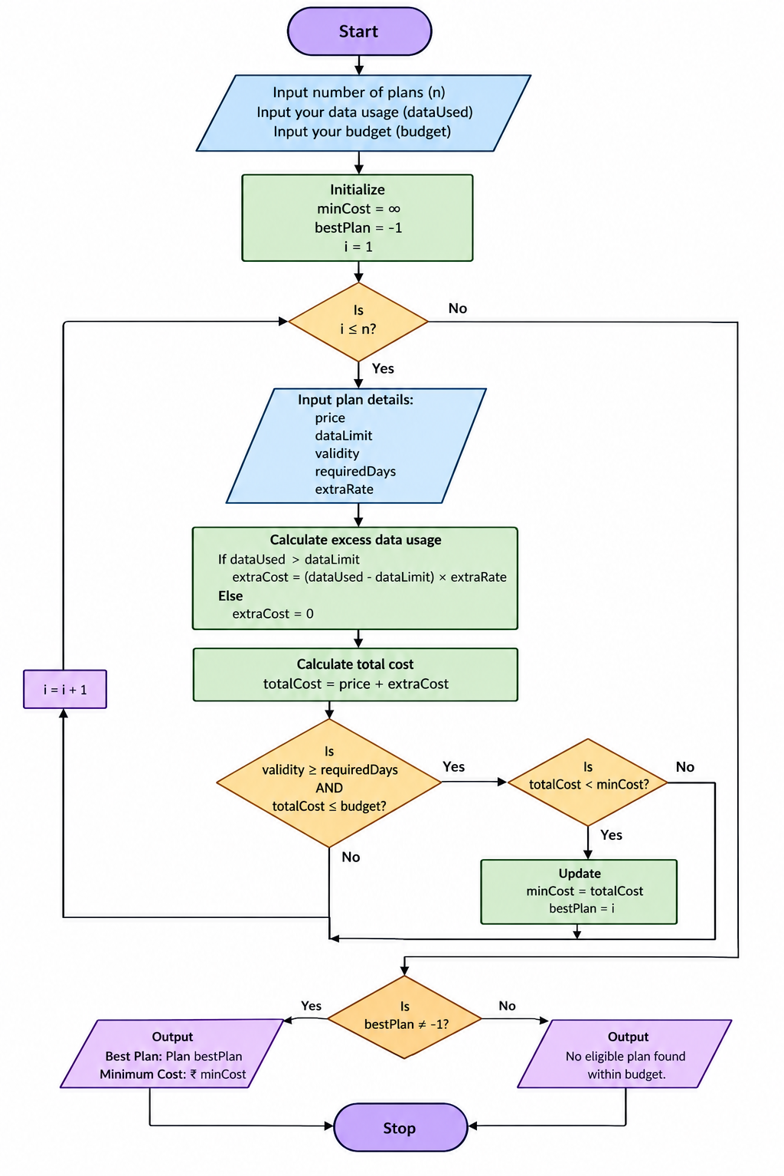
4. Pseudocode
BEGIN
INPUT n
INPUT dataUsed
INPUT budget

minCost = INFINITY
bestPlan = -1

FOR i = 1 TO n
INPUT price, dataLimit
INPUT validity, requiredDays
INPUT extraRate

IF dataUsed > dataLimit THEN
extraCost = (dataUsed - dataLimit) * extraRate
ELSE
extraCost = 0
ENDIF

totalCost = price + extraCost
DISPLAY totalCost

IF validity >= requiredDays AND
totalCost <= budget AND
totalCost < minCost THEN
minCost = totalCost
bestPlan = i
ENDIF
ENDFOR

IF bestPlan != -1 THEN
DISPLAY bestPlan, minCost
ELSE
DISPLAY "No eligible plan found"
ENDIF
END
SCREENSHOT
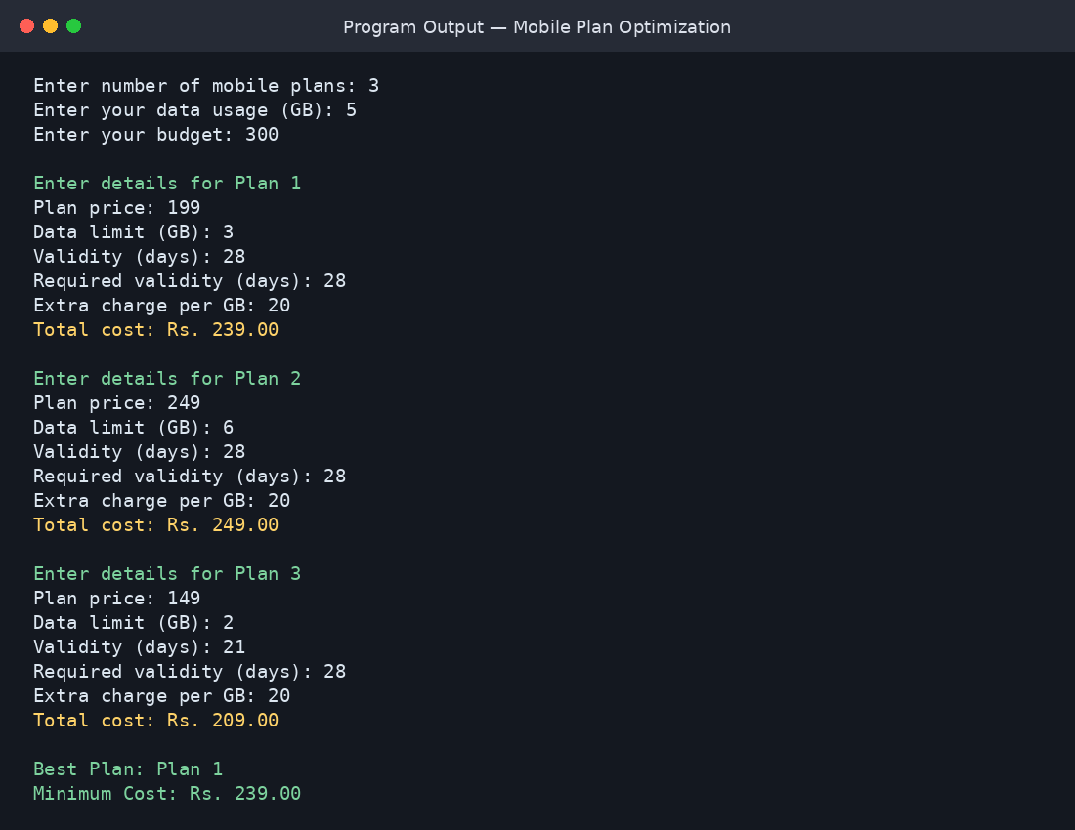
5. Sample Output
Example input: 3 plans, data usage 5 GB, budget ₹300, required validity 28 days.
Enter number of mobile plans: 3
Enter your data usage (GB): 5
Enter your budget: 300

Enter details for Plan 1
Plan price: 199
Data limit (GB): 3
Validity (days): 28
Required validity (days): 28
Extra charge per GB: 20
Total cost: Rs. 239.00

Enter details for Plan 2
Plan price: 249
Data limit (GB): 6
Validity (days): 28
Required validity (days): 28
Extra charge per GB: 20
Total cost: Rs. 249.00

Enter details for Plan 3
Plan price: 149
Data limit (GB): 2
Validity (days): 21
Required validity (days): 28
Extra charge per GB: 20
Total cost: Rs. 209.00

Best Plan: Plan 1
Minimum Cost: Rs. 239.00
Result: Plan 1 is the most economical eligible plan because it satisfies the validity and budget constraints and has the lowest total cost among eligible plans.

